Unit – 1
SYLLABUS : ASSEMBLERS & MACROS

Overview of Language processors – Assemblers: Design of two pass assemblers - single pass assemblers.
MACRO: Macro definition- macro call – macro expansion- nested macro advanced macro facilities- Design of Macroprocessor.

Language Processor
Introduction to Language Processing
As Computers became inevitable and indigenous part of human life, and several languages with different and more advanced features are evolved into this stream to satisfy or comfort the user in communicating with the machine , the development of the translators or mediator Software’s have become essential to fill the huge gap between the human and machine understanding. This process is called Language Processing to reflect the goal and intent of the process. On the way to this process to understand it in a better way, we have to be familiar with some key terms and concepts explained in following lines.
Language Translator
Is a computer program which translates a program written in one (Source) language to its equivalent program in other (Target) language. The Source program is a high level language where as the Target language can be any thing from the machine language of a target machine (between Microprocessor to Supercomputer) to another high level language program.
Two commonly Used Translators:-

1.Compiler
2.Interpreter

Compiler
Compiler is a program, reads program in one language called Source Language and translates in to its equivalent program in another Language called Target Language, in addition to this its presents the error information to the User.
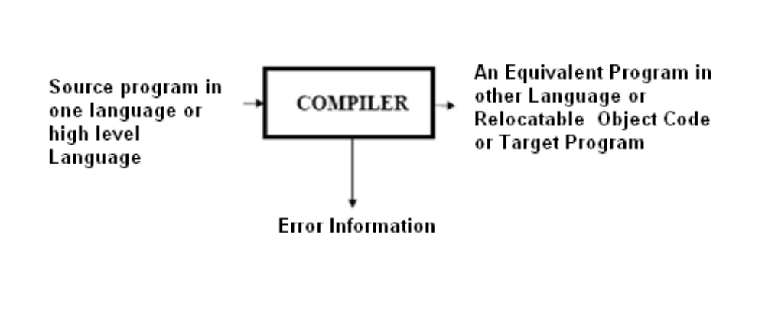
If the target program is an executable machine-language program, it can then be called by
the user to process inputs and produce outputs
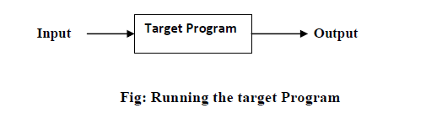
- Interpreter
An interpreter is another common kind of language processor. Instead of producing a target program as a translation, an interpreter appears to directly execute the operations specified in the source program on inputs supplied by the user.
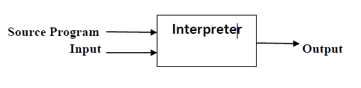

LANGUAGE PROCESSING SYSTEM
Based on the input the translator takes and the output it produces, a language translator can be called as any one of the following.

Preprocessor
A preprocessor takes the skeletal source program as input and produces an extended version of it, which is the resulted as expanding the Macros, manifest constants if any, and including header files etc. For example, the C preprocessor is a macro processor that is used automatically by the C compiler to transform our source before actual compilation. Over and above a pre-processor performs the following activities:
-Collects all the modules, files in case if the source program is divided into different modules stored at different files.
-Expands short hands / macros into source language statements.
Compiler
Is a translator that takes as input a source program written in high level language and converts it
into its equivalent target program in machine language. In addition to above the compiler also
-Reports to its user the presence of errors in the source program.
-Facilitates the user in rectifying the errors, and execute the code.
Assembler
Is a program that takes as input an assembly language program and converts it into its equivalent machine language code?
Loader/Linker
This is a program that takes as input are locatable code and collects the library functions, re
locatable object files, and produces its equivalent absolute machine code. Specifically the Loading consists of taking the re locatable machine code, altering the re locatable addresses, and placing the altered instructions and data in memory at the proper locations. Linking allows us to make a single program from several files of re locatable machine code.
In addition to these translators, programs like interpreters, text formatters etc., may be used in
language processing system. To translate a program in a high level language program to an executable one, the Compiler performs by default the compile and linking functions. Normally the steps in a language processing system includes Preprocessing the skeletal Source program which produces an extended or expanded source program , followed by compiling the resultant, then linking / loading ,and a finally executable code is produced. As I said earlier not all these steps are mandatory. In some cases, the Compiler only performs this linking and loading functions implicitly.

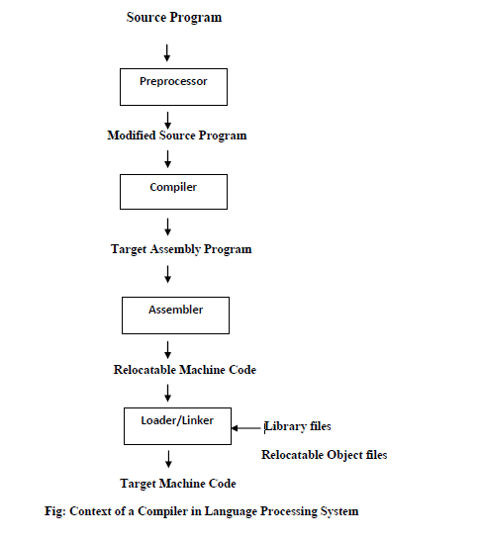

ASSEMBLERS
1. Introduction

There are two main classes of programming languages: high level (e.g., C, Pascal) and low level. Assembly Language is a low level programming language. Programmers code symbolic instructions, each of which generates machine instructions.

An assembler is a program that accepts as input an assembly language program (source) and produces its machine language equivalent (object code) along with the information for the loader.

Assembly language program
Assembler Linker EXE

Figure 1. Executable program generation from an assembly source code

Advantages of coding in assembly language are:
- Provides more control over handling particular hardware components
- May generate smaller, more compact executable modules
- Often results in faster execution

Disadvantages:
- Not portable
- More complex
- Requires understanding of hardware details (interfaces)

Assembler:

An assembler does the following:

1. Generate machine instructions
- evaluate the mnemonics to produce their machine code
- evaluate the symbols, literals, addresses to produce their equivalent machine addresses
- convert the data constants into their machine representations

2. Process pseudo operations

2. Two Pass Assembler

A two-pass assembler performs two sequential scans over the source code:

Pass 1: symbols and literals are defined
Pass 2: object program is generated

Parsing: moving in program lines to pull out op-codes and operands

Data Structures:

- Location counter (LC): points to the next location where the code will be placed

- Op-code translation table: contains symbolic instructions, their lengths and their op-codes (or subroutine to use for translation)

- Symbol table (ST): contains labels and their values

- String storage buffer (SSB): contains ASCII characters for the strings

- Forward references table (FRT): contains pointer to the string in SSB and offset where its value will be inserted in the object code

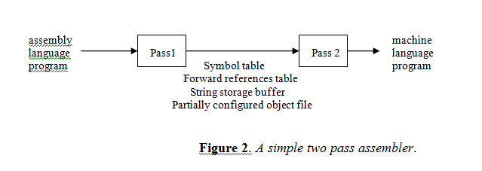

Example 1: Decrement number 5 by 1 until it is equal to zero.

assembly language memory object code
program address in memory
-----------------------
START 0100H
LDA #5 0100 01
0101 00
0102 05
LOOP: SUB #1 0103 1D
0104 00
0105 01
COMP #0 0106 29
0107 00
0108 00
JGT LOOP 0109 34
010A 01 placed in Pass 1
010B 03
RSUB 010C 4C
010D 00
010E 00
END

Op-code Table

Mnemonic | Addressing mode | Opcode
LDA | immediate | 01
SUB | immediate | 1D
COMP | immediate | 29
LDX | immediate | 05
ADD | indexed | 18
TIX | direct | 2C
JLT | direct | 38
JGT | direct | 34
RSUB | implied | 4C

Symbol Table

Symbol | Value
LOOP | 0103

Example 2: Sum 6 elements of a list which starts at location 200.

assembly language memory object code
program address in memory
-----------------------
START 0100H
LDA #0 0100 01
0101 00
0102 00
LDX #0 0103 05
0104 00
0105 00
LOOP: ADD LIST, X 0106 18
0107 01 placed in Pass 2
0108 12
TIX COUNT 0109 2C
010A 01 placed in Pass 2
010B 15
JLT LOOP 010C 38
010D 01 placed in Pass 1
010E 06
RSUB 010F 4C
0110 00
0111 00
LIST: WORD 200 0112 00
0113 02
0114 00
COUNT: WORD 6 0115 00
0116 00
0117 06
END

Symbol Table

Symbol | Address
LOOP | 0106
LIST | 0112
COUNT | 0115

Forward References Table

Offset | SSB pointer for the symbol
0007 | DC00
000A | DC05

SSB
DC00 | 4CH
DC01 | 49H | ASCII for L,I,S,T
DC02 | 53H
DC03 | 54H
DC04 | 5EH | ASCII for separation character
DC05

Pass1
- All symbols are identified and put in ST
- All op-codes are translated
- Missing symbol values are marked
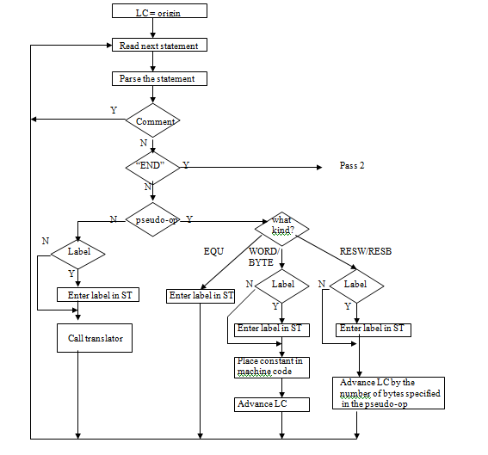

Translator Routine
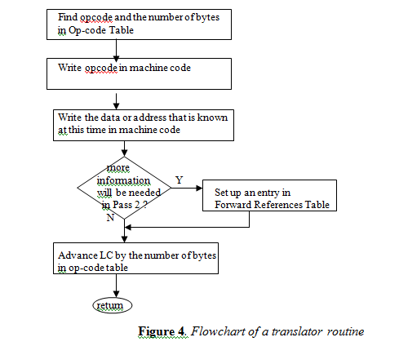

Pass 2
- Fills addresses and data that was unknown during Pass 1.

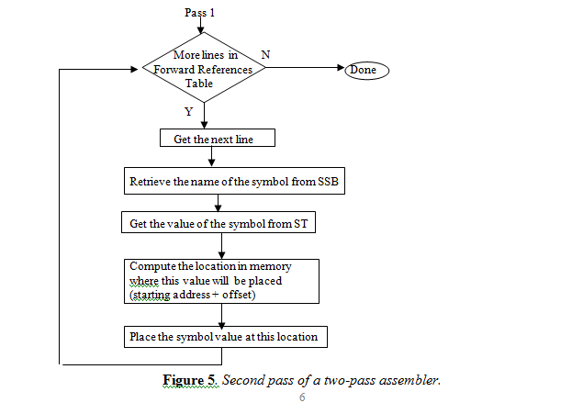

Relocatable Code
Producing an object code, which can be placed to any specific area in memory.

Direct Address Table (DAT): contains offset locations of all direct addresses in the program (e.g., 8080 instructions that specify direct addresses are LDA, STA, all conditional jumps...). To relocate the program, the loader adds the loading point to all these locations.

assembly language program Assembler machine language program
and DAT
Figure 6. Assembler output for a relocatable code.

Example 3: Following relocatable object code and DAT are generated for Example 1.

assembly language memory object code
program address in memory
-----------------------
START
LDA #0 0000 01
0001 00
0002 00
LDX #0 0003 05
0004 00
0005 00
LOOP: ADD LIST, X 0006 18
0007 00
0008 12
TIX COUNT 0009 2C
000A 00
000B 15
JLT LOOP 000C 38
000D 00
000E 06
RSUB 000F 4C
0010 00
0011 00
LIST: WORD 200 0012 00
0013 02
0014 00
COUNT: WORD 6 0015 00
0016 00
0017 06
END

DAT
0007
000A
000D

Forward and backward references in the machine code are generated relative to address 0000. To relocate the code, the loader adds the new load-point to the references in the machine code which are pointed by the DAT.

One-Pass Assemblers

Two methods can be used:

- Eliminating forward references
Either all labels used in forward references are defined in the source program before they are referenced, or forward references to data items are prohibited.

- Generating the object code in memory
No object program is written out and no loader is needed. The program needs to be re-assembled every time.

Multi-Pass Assemblers

Make as many passes as needed to process the definitions of symbols.

Example 3:

A EQU B
B EQU C
C DS 1

3 passes are required to find the address for A.

Such references can also be solved in two passes: entering symbol definitions that involve forward references in the symbol table. Symbol table also indicates which symbols are dependent on the values of others.

Example 4:

A EQU B
B EQU D
C EQU D
D DS 1

At the end of Pass1:

Symbol Table
A | &1 | B | 0
B | &1 | D |  |  | A | 0
C | &1 | D | 0
D |  | 200 |  |  | B |  |  | C | 0

After evaluating dependencies:

Symbol Table
A |  | 200 | 0
B |  | 200 | 0
C |  | 200 | 0
D |  | 200 | 0

